Physics Stage 3: Electricity and Magnetism
How Much Do You Know
Name: ANSWER KEY (60 marks)

- a. Draw the field around the two b. Draw the field around the current carrying
bar magnets below. (1 mark) wire below. (1 mark)
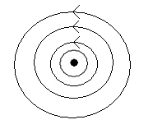

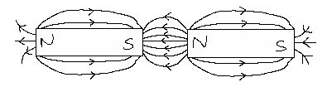

c. Draw the field around the combination. d. Draw the field around these two magnets.
(1 mark) (1 mark)
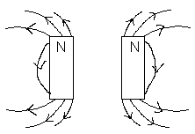
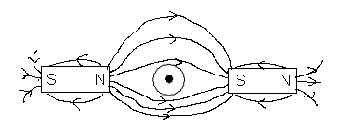

- In which direction will a wire move in the following situation? out of the page (1 mark)

- What is the direction of force on the wire in the following situations. (2 marks)

a. x x x x x x b. . . . . . . .
x x x x x x . . . . . . .
current
x x x x x x . . . . . . .
x x x x x x . . . . . . .
current

answer: top of the page answer: to left of page
- Near the north pole the Earth’s magnetic field is almost vertical. Is the field direction here vertically upwards, or is it vertically downwards? Explain your answer. (2 marks)

Vertically downwards.
The Earth’s geographic north pole is actually a magnetic south-seeking pole which has lines of force going into it (downwards) _______________________________________________________________________________________________________________________________________________________________________________________________________________________________________
- Given the following information, what is the value of resistor R? (3 marks)

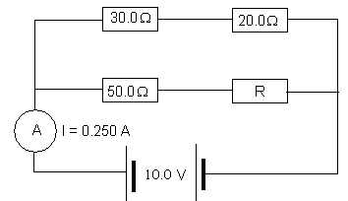
for top branch:
R_{T} = 30 + 20 = 50.0 Ω

V = 10.0 A
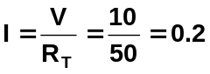 A

Current in lower branch

= 0.250 – 0.2
= 0.050 A

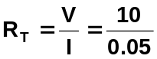 = 200 Ω

R_{T} = 50 + R
200 = 50 + R
R = 200 - 50
R = 150 Ω

- A wire 1.50 m long and carrying a current of 5.00 A is situated in a magnetic field of 10.0 T. What force does the wire experience if it is:
a. parallel to the field? (1 mark) b. at right angles to the field? (1 mark)

NIL F = BI

as both parallel to each other, = 10 x 5 x 1.5
no force experienced F = 75.0 N

- A rectangular coil of wire, 2.00 cm by 4.00 cm (as shown below), consisting of 200 turns is placed in a magnetic field of 2.00 x 10⁻² T. If a current of 4.00 A is flowing in the coil as shown,

  - In which direction will side CD move? (1 mark) out of the page

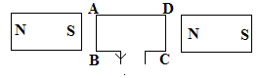

  - Find the force on side AB of the motor. (2 marks)

F = BI
= 0.02 x 4 x (100 x 0.02)
F = 0.320 N

  - Find the maximum torque experienced by the coil. (2 marks)

τ = 2Fr⊥
= 2 x 0.32 x 0.02
= 1.28 x 10⁻² Nm

- A rectangular coil of wire has 100 turns, a length of 2.00 cm and a width of 4.00 cm The coil is placed perpendicular to a magnetic field of 0.02 T. The coil is spun at 155 revolutions per minute. What is the average emf induced in the coil? (3 marks)

155 rev = 60 s 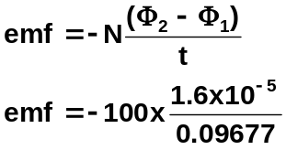
0.25 rev = t
emf = -0.0165 V
t = 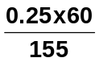
t = 0.09677 s

φ₂ = BA
= 0.02 x (0.02 x 0.04)
= 1.6 x 10⁻⁵ Wb

φ₁ = 0 Wb

- A student in a practical lesson set up a circuit consisting of a solenoid of 500 turns, a lamp and a transformer. She first connected the lamp, solenoid and transformer in series, with the transformer set on 12 V DC. Upon placing some iron rods in the centre of the coil, no obvious changes occurred. She repeated this with the transformer set on 12 V AC and this time found that the lamp dimmed and the rods vibrated and became hot. Explain the student’s observations. (3 marks)

Shows self-induction. On DC, magnetic field is unchanging. On AC, magnetic field varying so iron bar in changing magnetic flux so emf induced. Eddy currents in bar cause heating effect. In addition, back emf induced in coil which opposes applied emf and globe dims (less current)

- An all-metal plane, which is flying horizontally due East, has wing tips which are 30.0 m apart. If the vertical component of the earth’s magnetic field at this point is 6.00 x 10⁻⁵ T upwards, calculate the induced emf when the aircraft is travelling at a speed of 3.00 x 10² km h⁻¹.
(2 marks)

v = 300 km h⁻¹
= 83.33 m s⁻¹ emf = Blv
= 6.00 x 10⁻⁵ x 30 x 83.33
= 0.150 V

- Two parallel wires carry current of 3A and 4A respectively as shown below. In what direction is the magnetic field at point R, which is midway between the wires? (1 mark)

R

Answer: into page

- Consider the following situation in which the north end of a magnet is approaching an aluminium ring. Which of the following answers is correct? (1 mark)

N Answer: C

  - A current is induced in a clockwise direction setting up a north pole.
  - A current is induced in a clockwise direction setting up a south pole.
  - A current is induced in an anticlockwise direction setting up a north pole.
  - A current is induced in an anticlockwise direction setting up a south pole.

- The Earth’s magnetic field is about 50 μT. Estimate the maximum amount of magnetic flux that could be enclosed by a netball ring. (2 marks)

assumptions φ = BA
r = 0.2 m = 50 x 10⁻⁶ x π(0.2)²
A = πr² = 5.28 x 10⁻⁶ Wb

- Look at the following coils:

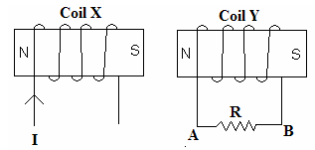

  - What is the direction of the induced current through R while the magnetic flux density is decreasing? (2 marks)

needs to increase so north on left side B → A

  - Given that the area of each loop of the coil is 1.00 x 10⁻² m² and the flux decreases from 0.500 Wb to 0.200 Wb in 2.00 s, find the magnitude of the induced emf in each loop.
(2 marks)

A = 1.0 x 10⁻² m² 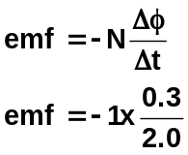
Δφ = 0.5 – 0.2
= 0.3 T emf = -0.150 V
t = 2.0 s

- No motor is 100% efficient. Consider a starter motor in a car which is 60.0% efficient. To operate it needs 1.10 kW to start the 12.0 V battery. What current will it need to draw in order to operate? (2 marks)

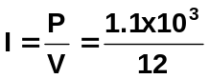= 91.67 A

but 60% efficient so 91.67 x 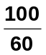

so I = 153 A

- My portable stereo runs on 10.0 V, but can be connected safely to the 250 V mains through a power cord with a ‘black box’ in it.

  - What is the black box called? (1 mark) Step-down transformer
  - Sketch a labelled diagram of the device inside the black box, showing the input and output.
(1 mark)
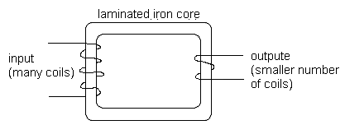

  - If the secondary coil has 30 turns, how many turns has the primary coil? (2 marks)

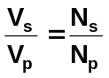 ; 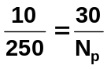
N_{p} = 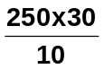 = 750 turns
number of turns = 750

- How do power companies minimized the loss of power incurred in transmitting electricity through power lines, and explain why less power is lost this way? (3 marks)

To minimize power loss it is transmitted at high voltage.
As P = IV, the higher the voltage, the lower the current.
Power loss as heat depends an the square of the current, P = I²R so the lower the current the less the power lost as heat for same quantity of power transmitted.

- An Aluminium disc rotates on a spindle. When a strong horseshoe magnet is placed so that the disk is within the magnet, the disk is rapidly slows down and stops. Explain why. (3 marks)

As the aluminium disc is rotating this creates a changing magnetic field in the disc.
The changing magnetic field induces an emf in the disc which in turn produces Eddy currents in the disc and an induced magnetic field.
This induced magnetic field is opposite the field of the horseshoe magnet and therefore opposes the motion of the disc causing it to slow down.

- Draw the electrical field for the following situations:

a. two positive charges b. positive charge above a negative plate
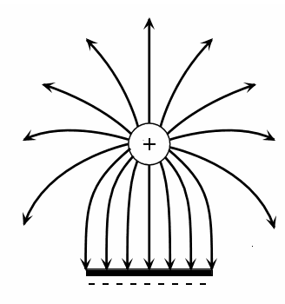
(2 marks) (2 marks)
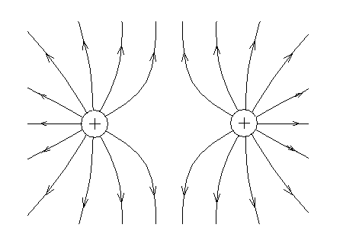

- An electric kettle is rated at 2.20 kW when connected to a 240 V supply. The kettle runs for 2.50 minutes.
  - What current runs through the heating element? (2 marks)

P = VI
I = 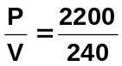
I = 9.17 A

  - How much electrical energy is converted to heat energy? (2 marks)

W = VIt
= 240 x 9.1666 x (60 x 2.5)
W = 3.30 x 10⁵ J

  - What charge flowed through the kettle in this time? (2 marks)

q = It
= 9.1666 x 2.5 x 60
q = 1375
q = 1.38 x 10³ C

- An electrician needs to add a fuse into an electrical circuit in a factory. She has a choice of 1.00 A, 2.00 A, 5.00 A and 10.0 A. The total power drawn from the circuit will be 450 W with a total resistance of 115 Ω. Which fuse should she use so as to ensure that the electrical devices operating on that circuit will not be damaged by excess current? (3 marks)

P = I²R
450 = I² x 115
I = 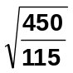
I = 1.98 A
so the electrician needs a 2.00 A fuse

